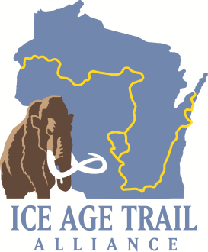 | "In the Mud" Award  Nomination Form

The "In the Mud" award is given to IATA member volunteers who display dedication to the mission and goals of the IATA and a willingness to roll up their sleeves on behalf of the Ice Age Trail. An In the Mud recipient:

* Consistently shows up at workdays and dives into the dirty work
* Makes significant efforts to establish the Ice Age Trail
* Epitomizes the bedrock volunteer spirit responsible for building trail

Nominee information

Name:
Address:
Phone:
Email:
Chapter:

This person is being nominated for the "In the Mud" award because:

Nominated by:

