I (Michael Maziarka) will be leaving from Interstate State Park in St. Croix Falls, WI. That is the Ice Age National Scenic Trail’s (commonly referred to as the IAT) western terminus. It will be myself and one other veteran, Miles Vining, a Marine veteran from Indiana. We plan to hike between 80-110 miles per week.

Each Saturday we will be picked up by someone from a VFW located near our location for that week. This is an awesome support chain of veterans in towns along the trail that Warrior Hike arranged for us. They will pick us up from the trail, let us rest for a day, give us food, house us for a night, be generally awesome and supportive, and send us on our way the next day to complete another week’s worth of hiking.

Now, for Warrior Hike. This is a non-profit organization founded by Sean Gobin, a Marine veteran who hiked the Appalachian Trail when he got out of the military. The purpose of Warrior Hike is to enable combat veterans to complete amazing expeditions for their known therapeutic benefits.

From their website, "Following in Earl Shaffer’s footsteps and in recognizing the therapeutic effects of long distance outdoor expeditions, Warrior Expeditions created the Warrior Hike, Warrior Bike, and Warrior Paddle programs which are designed to help combat veterans transition from their military service."

The reason I am doing this is to be part of something larger than myself, something that connects me to an amazing veterans' community. There is no doubt that hiking a long distance like this will be an experience of a lifetime, and I feel honored to be part of Warrior Hike.

Warrior Hike supports the veterans they sponsor through providing gear for them (from VERY generous sponsors), arranging support in trail towns with veterans' and VFW groups (as mentioned above), as well as anything else a veteran may need while on their journey. Sean is amazingly helpful and he has a great staff that work tirelessly to make sure that every single veteran that they support has the means necessary to complete their expedition.

I was in the US Army from 2010-2014. I deployed once to Afghanistan from 2012-13.

PLEASE check out the Warrior Hike website if you need any more info about the organization. https://warriorexpeditions.org
You can also find a calendar and map of our Ice Age Trail hike on the website under the “calendar” and “expeditions” tabs.

They also have a Facebook page and I would love it if people would “like” and ‘follow’ their page to receive updates if interested. There will pictures weekly! https://www.facebook.com/warriorhike

Thank you for your interest! I hope this wasn’t an overload of information. I just get so excited to think I’m part of something so awesome. Also, that there is a group of people out there making this possible for veterans. How cool!!

If you need anything else, please feel free to contact me on the phone or by email. Once I’m on the trail it will be a little more difficult to get in touch with me, but I’ll do everything possible to accommodate.

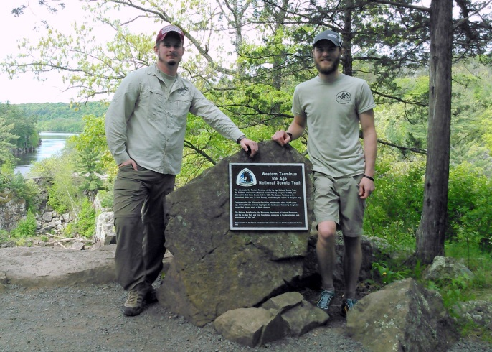
The 2016 Warrior Hike veterans (L to R, Miles Vining and Michael Maziarka) arrive at the Western terminus of the Ice Age Trail to begin their 1,200 mile trek across the state of Wisconsin.

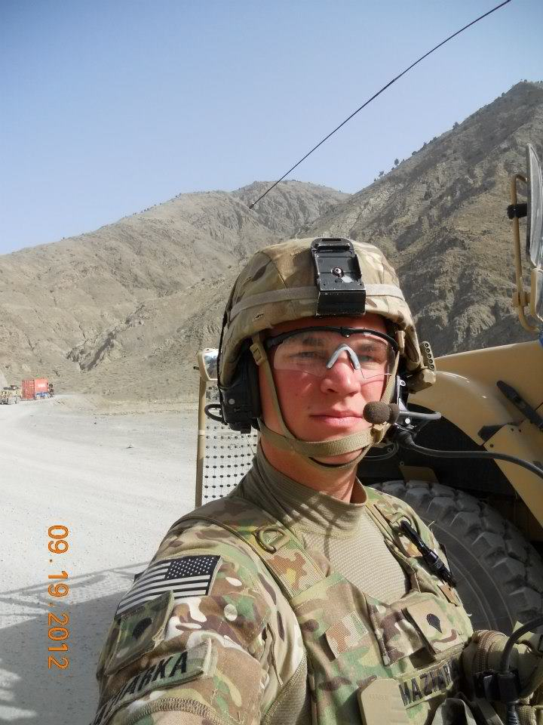
Michael Maziarka, United States Army (2010-2014), La Crosse, WI
Deployment: Afghanistan

Miles Vining, US Marine Corps (2010-2014), from Bloomington, IN
Deployment: Afghanistan

