Volunteer Application – Property Monitoring
Thank you for your interest in volunteering with the Ice Age Trail Alliance’s Property Monitoring program. Please complete this volunteer application to help us ensure this program is a fit for you. Thank you for your interest in Property Monitoring.
Name: _____________________________________________________________________________
Email: ______________________________________________________________________________
Phone: _____________________________________________________________________________
Address: ____________________________________________________________________________
State: __________
Date: __________________________________
Have you volunteered with the Ice Age Trail Alliance in the past? If so, in what capacity (e.g. chapter, Mobile Skills Crew, trail maintenance, etc.)

What about monitoring properties appeals to you?

How far are you willing to travel to monitor properties?
20 miles 50 miles 100 miles almost any distance
Do any of the following apply to you? Note, we provide training for some of these.
Good at map reading/wayfinding ____ Read a compass ____ Use a GPS unit ____
Good at talking with new people ____ Willingness to bushwhack/walk off trail ____
Basic knowledge of digital photography (do you have a non-phone camera?)_____
We expect property monitors to monitor multiple properties over several consecutive years during the same season (ie. spring of fall). Are you able to commit to this requirement?

Are you willing and able to attend a property monitoring training for one day during IAT-U August 18-21, 2016 (currently scheduled for the 21st but flexible)?

PLEAS E COMPLETE THIS APPLICATION AND GIVE/SEND/EMAIL TO KEVIN THUSIUS
Po Box 128, Cross Plains, WI 53528 or kevin@iceagetrail.org
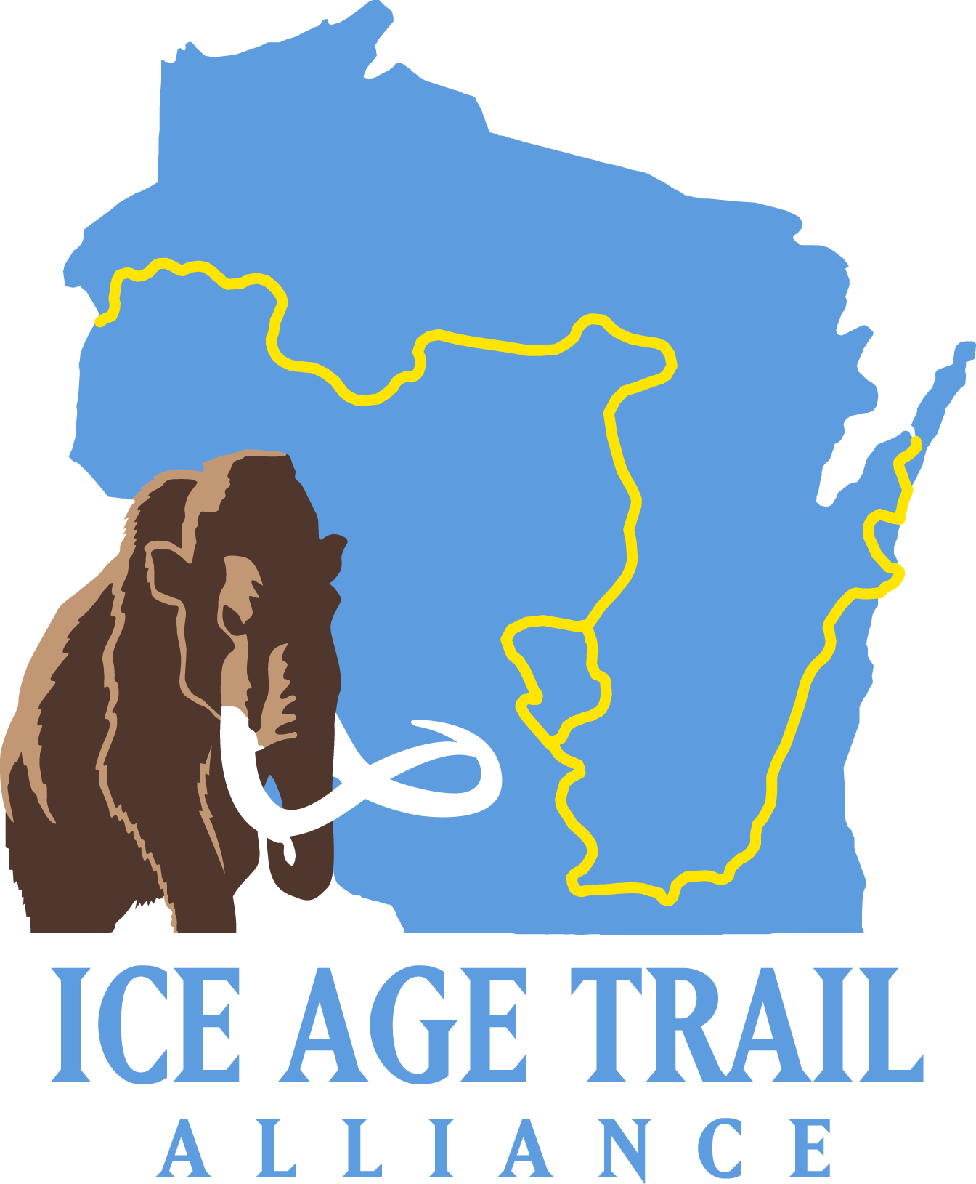
The Ice Age Trail Alliance manages more than 140 properties covering some 3,500 acres in order to help permanently protect the Ice Age National Scenic Trail. Each of these properties must be monitored annually. The main reasons to monitor these properties is to: uphold and defend the terms of our easement; to keep the landowner aware of the conservation values of their land and the terms of the easement; to ensure proper use and enforce misuse on fee owned lands; and to show that the land trust is a responsible easement holder and landowner by monitoring on a regular basis and keeping good records.

The Alliance is seeking a team of exceptional volunteers who are willing to monitoring several of these property interests around the state. This entails visiting the property each spring or fall, noting any issues using GIS units/cameras and then completing the proper records. This is an incredibly import task that can be highly rewarding. The Alliance will provide training to interested and qualified applicants.

Training is scheduled to take place during Ice Age Trail University (IAT-U) August 18-21, 2016 (tentatively scheduled for the 21st).

If you or someone you know is interested please complete an application and get it to Kevin Thusius as soon as possible -space is limited.

Kevin Thusius
Director of Land Conservation
PO Box 128
2110 Main Street
Cross Plains, WI 53528
kevin@iceagetrail.org

