LANGLADE COUNTY ICE AGE NATIONAL SCENIC TRAIL CONDITIONS
(As of November 14, 2021)
COVID-19
All five Ice Age Trail segments in the county are open for hiking. However, hikers are encouraged to keep an appropriate distance when encountering other hikers on the trail. Also having a facemask handy if close encounters with others is recommended.

Due to situations beyond the control of the Langlade County Ice Age Trail Chapter, conditions are constantly changing. Hikers are urged to contact the chapter coordinator (715-623-2645) or the Langlade County Forestry Department Office (715-627-6300) at the Fairgrounds to check on current conditions in advance of any hike.
"You Are Here" signs, installed in 1997, are at select sites or where the trail crosses public roads on the Kettlebowl, Lumbercamp and Parrish Hills Segments.
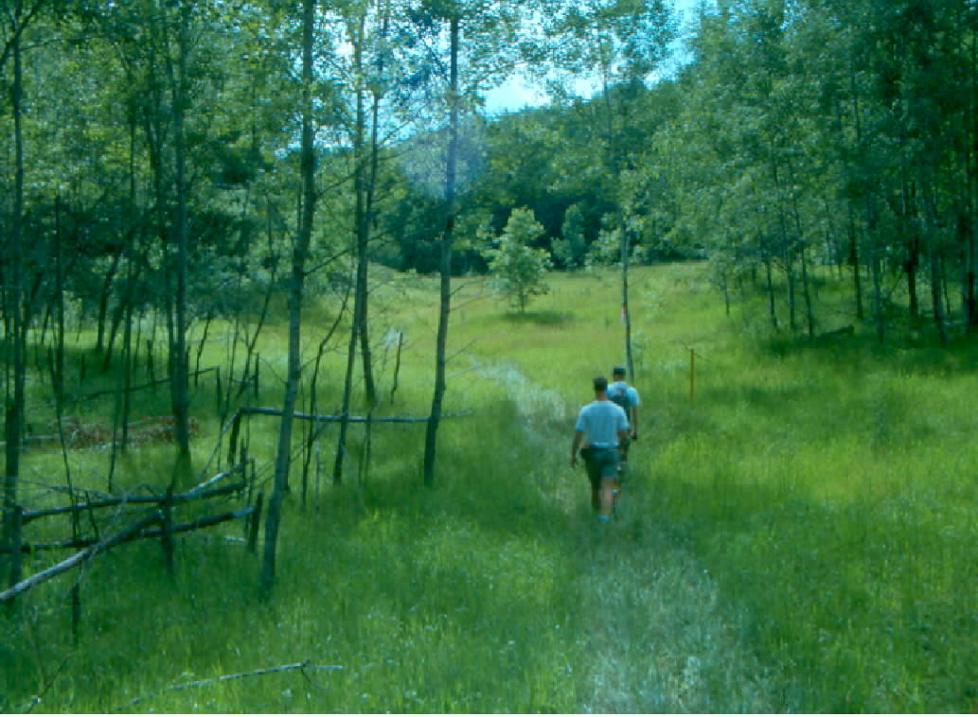
Frost pocket on the Kettlebowl Segment
KETTLEBOWL – Distance: Approximately 15 miles Highway 52 to Polar at Highway 64.
The private landowner on the south end of the Kettlebowl Segment notified the chapter of logging activity starting Monday, September 27, 2021. The landowner also requested that hikers avoid the area so the segment is closed until logging is completed. Closure notices are posted at the Wisconsin 52 and Sherry Road Trail Heads. The completion date is unknown at this time. For more information, please call 715-623-2645.
The Kettlebowl Segment trail head on Sherry/Oak Roads was moved over a half-mile southeast to a new location on Sherry Road. The trail was also extended a third of a mile to the new trail head which is closer to a county-owned parking lot. The lot accessible by a short road walk via Sherry Road offers safe and legal parking space for hiker vehicles. A Langlade County ordinance prohibits parking on town and county roads unless authorized by the governing body. Violators of the ordinance can be ticketed and have their vehicles impounded. (See map below for details of the segment extension).
Brushing and markings were refreshed where needed from Sherry Road north to the Kettlebowl Ski Hill at Highway 52 this year. Seasonal growth of trees screen markings so be alert. Drainage of a large pool of water on the trail was completed last year by volunteers with channel clearing this fall.
The segment passes through some of the highest terrain in Langlade County and features scenic hardwood ridges and frost pockets. Near to the trail is Kent Hill at 1903 feet above sea level which is the county’s highest point of elevation. Big Stone Hole, a unique glacial feature, is just off the trail but access is unimproved, so caution is advised.

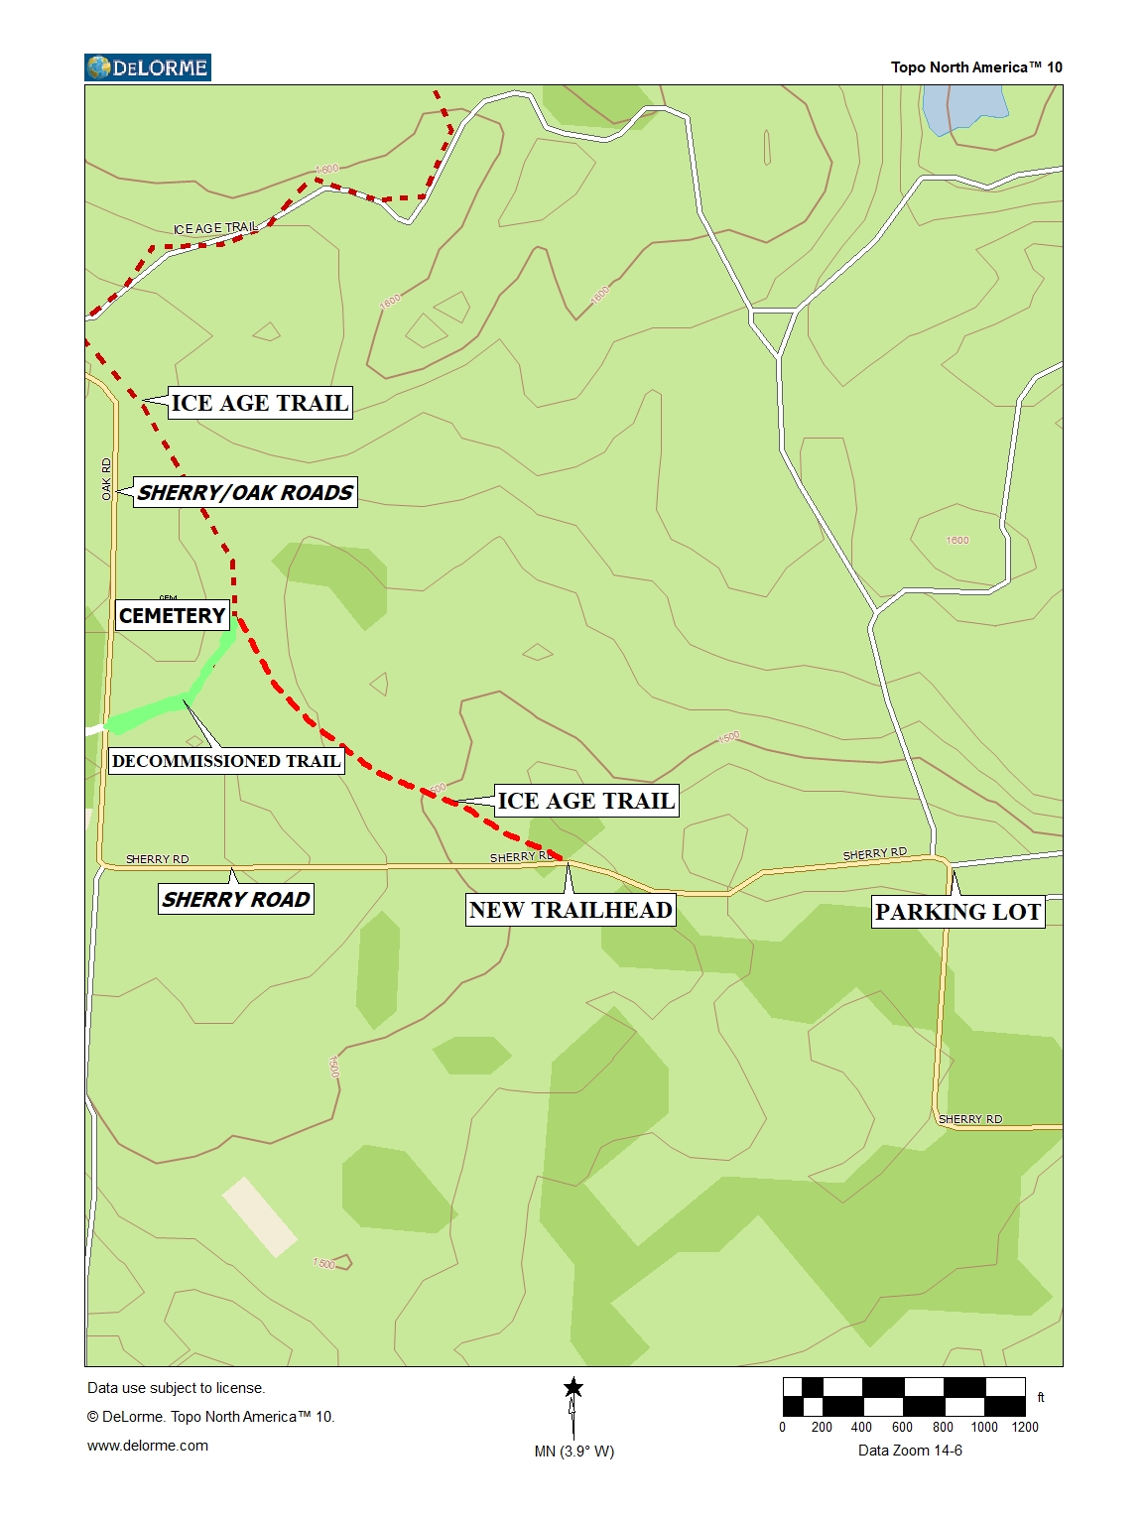

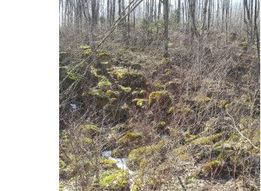
Boulder field on South Slope of Summit Lake Moraine east of Baker Lake - Photo by Lee Auner LUMBERCAMP - Distance: 12 miles Wisconsin 52 to County Trunk A
An incomplete logging operation affects a half mile of the segment just west of Baker Lake (see following map). The operation is currently inactive but is projected to be completed sometime this winter. When that occurs, a notice will be posted online. When logging resumes on the steep, boulder strewn trail, hikers should be alert and exercise extreme caution in the area to falling timber, chain sawing and equipment movement.
The logger used Otto Mauk Road to the west of the operation for log storage and hauling to WI 52 so hikers should also be alert and cautious in this area. With logging completion, the trail over the forest lane connecting the operation with Otto Mauk Road will be graded to remove several water depressions and provide a smother surface.
The stretch especially west of Otto Mauk Road to County Trunk S has an inordinate amount of use by 4-wheel vehicles. With the abnormal rain this summer, pools of water have collected in depressions formed by the vehicular traffic. Caution is advised in these areas.
Brushing and directional arrows at critical intersections and markings were refreshed this year from Wisconsin Highway 52 west to County A. Access to parking at the north end of Hill Road is not available currently as a deep pool of water covers the entire width of the town road and beyond. High water levels have caused an overflow of the shallow glacial lakes in the Peters Marsh Wildlife Area affecting the trail between County Highways S and A. The Peters Marsh section was mowed during the fall by DNR staff.
Local sportsmen have fixed up the stone cellar at the former Norem Lumbercamp site just west of Otto Mauk Road for overnight use. The chapter is not responsible for the accommodations but hikers are encouraged to exercise good trail stewardship if using the historic structure.
The boulder strewn slope near Baker Lake, a former logging camp and the state’s Peters Marsh Wildlife Area are noted features of this segment. The east end of the segment has rugged terrain which is part of a recessive moraine known as the Summit Lake Moraine which stretches from Oneida County through Langlade County into Oconto County.

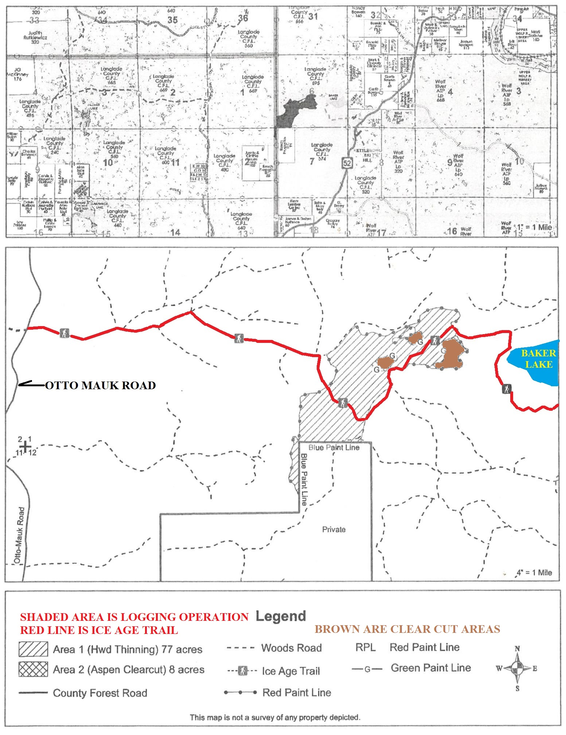.

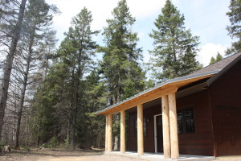
Spychalla Lodge-Summit Moraine Segment at County Trunk J.
Summit Moraine - Distance: 12.4 miles County Trunk A to County Trunk B
Rerouting of this segment was completed in 2018. The reroute involved establishment of new trail sections and upgrading existing stretches. The segment utilizes a part of the popular Jack Lake Cross Country Ski system. Winter hikers are encouraged to avoid disturbing the groomed track maintained for skiers.
The privately owned stretch between US 45 and County B is closed during the gun deer season. A temporary on-road bypass is available via County J to the trail west of County B. Caution should be on the stretches of the county roads.
Salvage logging occurred recently on the segment east and west of Pence Lake Road. Caution should be exercised in these areas.
The entire segment was checked this summer with mowing, brushing and markings refreshed. New You Are Here signs at four locations on the segment were installed this summer.
Caution should be exercised on the trail section along the busy and high-speed County A. Parking of vehicles at any gated areas on County A is prohibited by county ordinance and the DNR. There is an enlarged parking area provided by the DNR on the south side of County A.
Hikers are encouraged to use this parking area and those at County B, Veterans Memorial Park or the Jack Lake Cross Country Ski on County J to avoid the volume of highspeed traffic on US 45/WI 47. There is no safe off-road parking space along the busy highway.
Depending on varying lake levels, the bog walk at Game Lake may not be safely passable, but hikers can follow a 0.2 mile longer portion of the nature trail around the lake as a bypass option to connect east or west with the Ice Age Trail. Features of this segment are Veterans Memorial Park, the bog walk and Spychalla Lodge. The latter facility is open but overnight use is discouraged. There are two fee campsites along the segment on Game and Jack Lakes along with the no-fee designated camp area (DCA) at Upper Ventor Lake. Ice Age Trail Alliance rules prohibit campfire at DCAs so observance of the rule is appreciated by other hikers and local volunteers.
Veterans Memorial Park on Jack Lake is a county park with cabins, developed campground, picnic area, a beach and native plant arboretum. Some hikers have used the county park as a base camp for their treks.
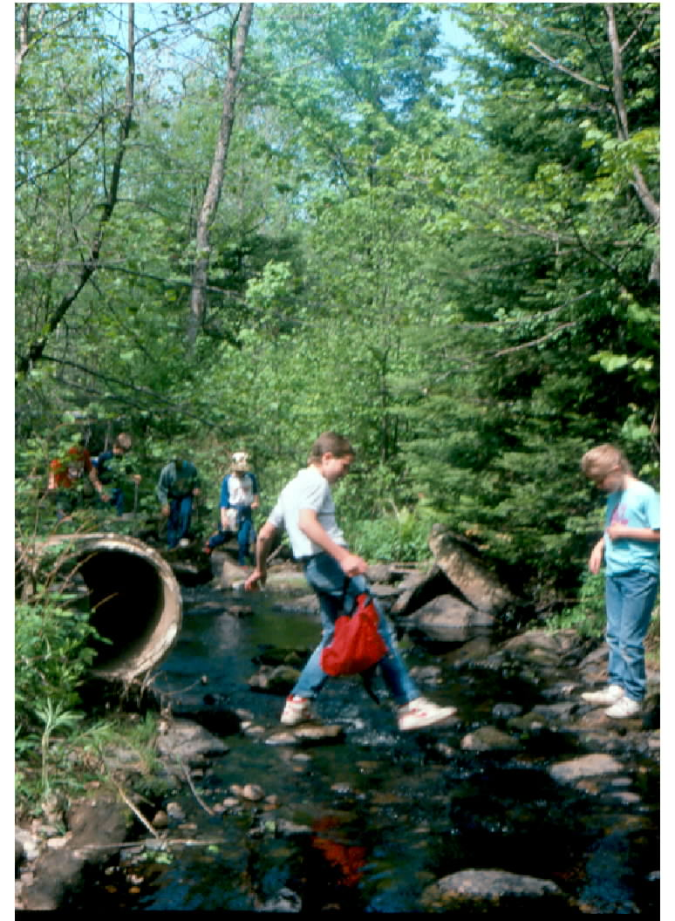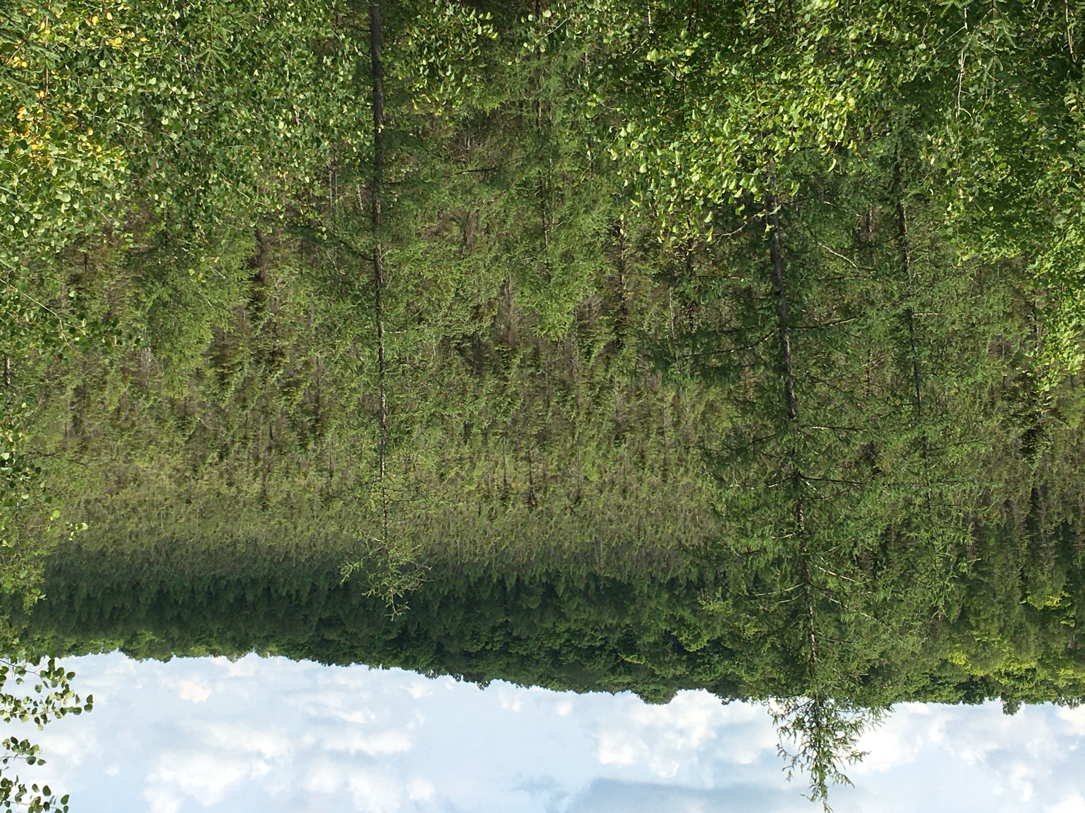
Crossing the West Branch of the Restored vista along Highland Lakes (Restoration and photo
Eau Claire River. Babbling by Lee Auner.) Restoring the view required experience and
brook or raging torrent? skill to clear the brush along the edge of some steep slopes.
HIGHLAND LAKES - Distance: 12.5 miles County Trunk B to County Trunk T.
Several town road signs on the Forest Road connecting route between Camp Susan and Kleever Road were stolen recently. Westbound hikers especially need to be aware of the situation and turn at the next west bound road (Kleever, unsigned currently) a quarter mile south of Learman Road which is signed.
In 2009, the Knights Templar Club granted permission for the trail to cross their land on a section of a forest lane north of Kleever Road. Gates and trail markings were installed on the stretch the following year. Brushing, refresher markings and directional arrows at critical intersections were completed this spring.
This segment is incomplete but a 4.5 mile connecting route is available via Forest and Kleever Roads in the Town of Upham between trail heads at County B and T. An interesting feature on Forest Road is the Bogus Swamp State Natural Area. Watch for the state marker about the unique site on the east side of the road. The marker is less than a mile north of the Bogus Road junction with Forest Road.
A mile south of County T, a scenic vista was skillfully restored this summer. The view overlooks a Spruce/Tamarack swamp, once a former shallow glacial lake, framed by the north side of the Parrish terminal moraine. The natural process of eutrophication over the ages eventually converted the water body to a wetland from sediment run-off and organic material deposition. Bogus Swamp on the Forest Road connecting route is another example created by the natural process.
The Parrish terminal moraine is a distinctive landform which stretches over 26 miles from Bryant to Parrish and was deposited by the Langlade lobe of the Wisconsin glacier. Langlade County contains portions of terminal moraines deposited by three of the six ice lobes of the last glacier which shaped the state’s landscape.
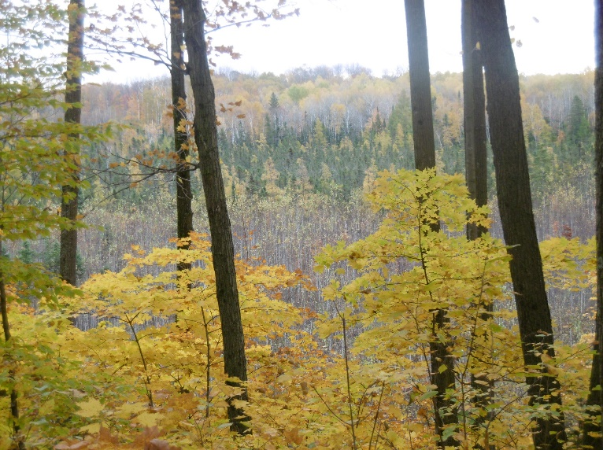
Just east of Nelson Fire Lane, the vista east from “Blackberry Ridge”. Photo by John Prokops
PARRISH HILLS - Distance: 12 miles County Trunk T to the Lincoln County Line A tornado in 2011 devastated a portion of the segment south of 5 Cent Road. A re-route via ATV/UTV trails on the Parrish Game Trail Fire Lane and 5 Cent Road is provided until the damaged stretch is re-established. Activity to move the stretch from the ATV trail is expected this year.
Depending on ground water levels, the segment has several water crossings which require a bit of creativity to get around them.
Beaver activity continues to offer wet stretches in the Old Truck Marker area 2.5 miles north of the trail head on County T.
Some renewed beaver activity is occurring at the bridge a half mile north of Townline Lake. A beaver dam has raised water levels which affects safe and dry passage over the narrow wood structure. The situation is being monitored with a possible by-pass of the stream crossing if unresolved before conditions do not allow safe and dry passage.
A few downfall trees were reported at scattered locations and awaiting removal. Brushing and refreshing of trail markings along with some mowing were completed this summer.
Hikers may encounter a No Trespassing sign on the rail grade just west of Pine Road in Parrish.
However, the landowner has granted permission for hikers to pass over his property.
The segment has a ford across the Prairie River southeast of Parrish. The river bottom is firm and the water level is usually below the knees. Mucky stretches just north and south of the river can be expected. Last winter the river froze to allow dry crossings but six days later the stream was flowing.
Logging was partially completed on the stretch between the Nelson and Parrish Game Trail Fire Lanes and the state-owned property south of the Prairie River. Logging will be occurring in areas near the trail so hauling traffic may be encountered. Caution is advised in these areas when any logging operation is active.
There is an ATV shelter with water and pit privies just north of Five Cent Road. The facility, a half mile south of the trail crossing, is available to hikers. However, camping in proximity to the shelter is not permitted. Available for primitive camping is an Adirondack-like shelter on the trail about a mile southeast of the Prairie River ford.
Northwoods Chapter members regularly check the stretch from County Trunk H west into Lincoln County.
Features of the Parrish Hills Segment include the Old Truck Marker, natural lakes, wetlands,
“Blackberry Ridge”, the Prairie River ford and the hamlet of Parrish where oil exploration occurred in the county’s early years. Another notable feature is Baldy Hill, the eastern prominence of the Harrison Hills terminal moraine deposited by the Wisconsin Valley Lobe of the last glacier over 11,000 years ago.

