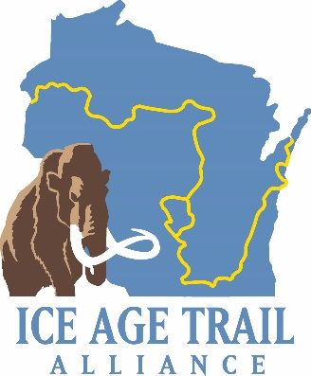
Overview
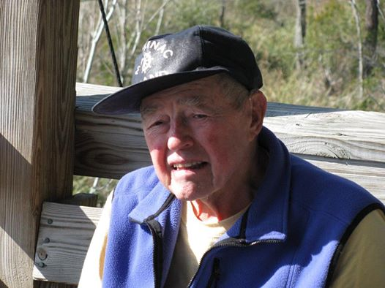The Ice Age Trail Alliance is pleased to announce the Douglas “Stickman” Sherman Scholarship. This award serves as an honor to Mr. Sherman and his endearing gifts to Saunters participants for many years. Doug’s steadfast dedication to providing custom-made hiking sticks for youth explorers will last forever. The gifts quickly led to Doug’s trail name of “Stickman.” Initial funding for the scholarship was provided through gifts made in his memory after he passed in 2014.
For weeks on end, youth carried Doug’s creations all across Wisconsin – along the shores of the Wisconsin River, on towering bluffs overlooking Devil’s Lake, through the deepest north woods, around the crags of Eau Claire Dells, and among vast prairies. The sticks provided balance, confidence and a helping hand. In essence, “Stickman” was there to help guide each hiker, showing them the way and giving them a boost when they stumbled. He was with them every step of the way, exploring the Ice Age Trail and instilling a steady calm that only the solace of nature can provide.
Criteria
Stickman’s guiding efforts will be extended once again through the Ice Age Trail Alliance’s Douglas “Stickman” Sherman Scholarship. The scholarship is worth a one-time award of $500 and paid upon student submission of college transcript with a GPA of 2.5, or the equivalent, for the first semester of study. Students interested in applying for the scholarship will meet the following criteria:
A completed application submitted to and received by the IATA as described, reflecting an applicant’s:

  - History of volunteering with the Ice Age Trail Alliance and/or serving as a mentor during Saunters events.

  - Love of the Ice Age National Scenic Trail and a desire to create, support and protect the trail for future generations.

  - Future goals including a degree in the environmental, educational or related fields.

Douglas “Stickman” Sherman Scholarship Application

- Applicant’s Name and age
- Address
- Email and/or Phone
- Year applicant will graduate
- High school applicant attends
- Briefly list the types of volunteer work and/or mentoring you have done in conjunction with an Ice Age Trail Alliance activity and the year(s).

- What is the most important quality of the Ice Age Trail that should be shared with younger generations? Why?

- Describe a moment during your work with the Alliance that had a significant impact on you or a youth you were mentoring.

- Describe how your time on the Ice Age Trail has influenced your future goals.

All submissions must be postmarked by September 30 and sent to the following:

Ice Age Trail Alliance
Attn.: Stickman Scholarship
PO Box 128
Cross Plains, WI 53528

All applications will be reviewed by the Alliance’s Awards Selection Committee and a final selection will be made at the end of each year. The scholarship recipient will be recognized at the Ice Age Trail Alliance’s Annual Conference the following April.

