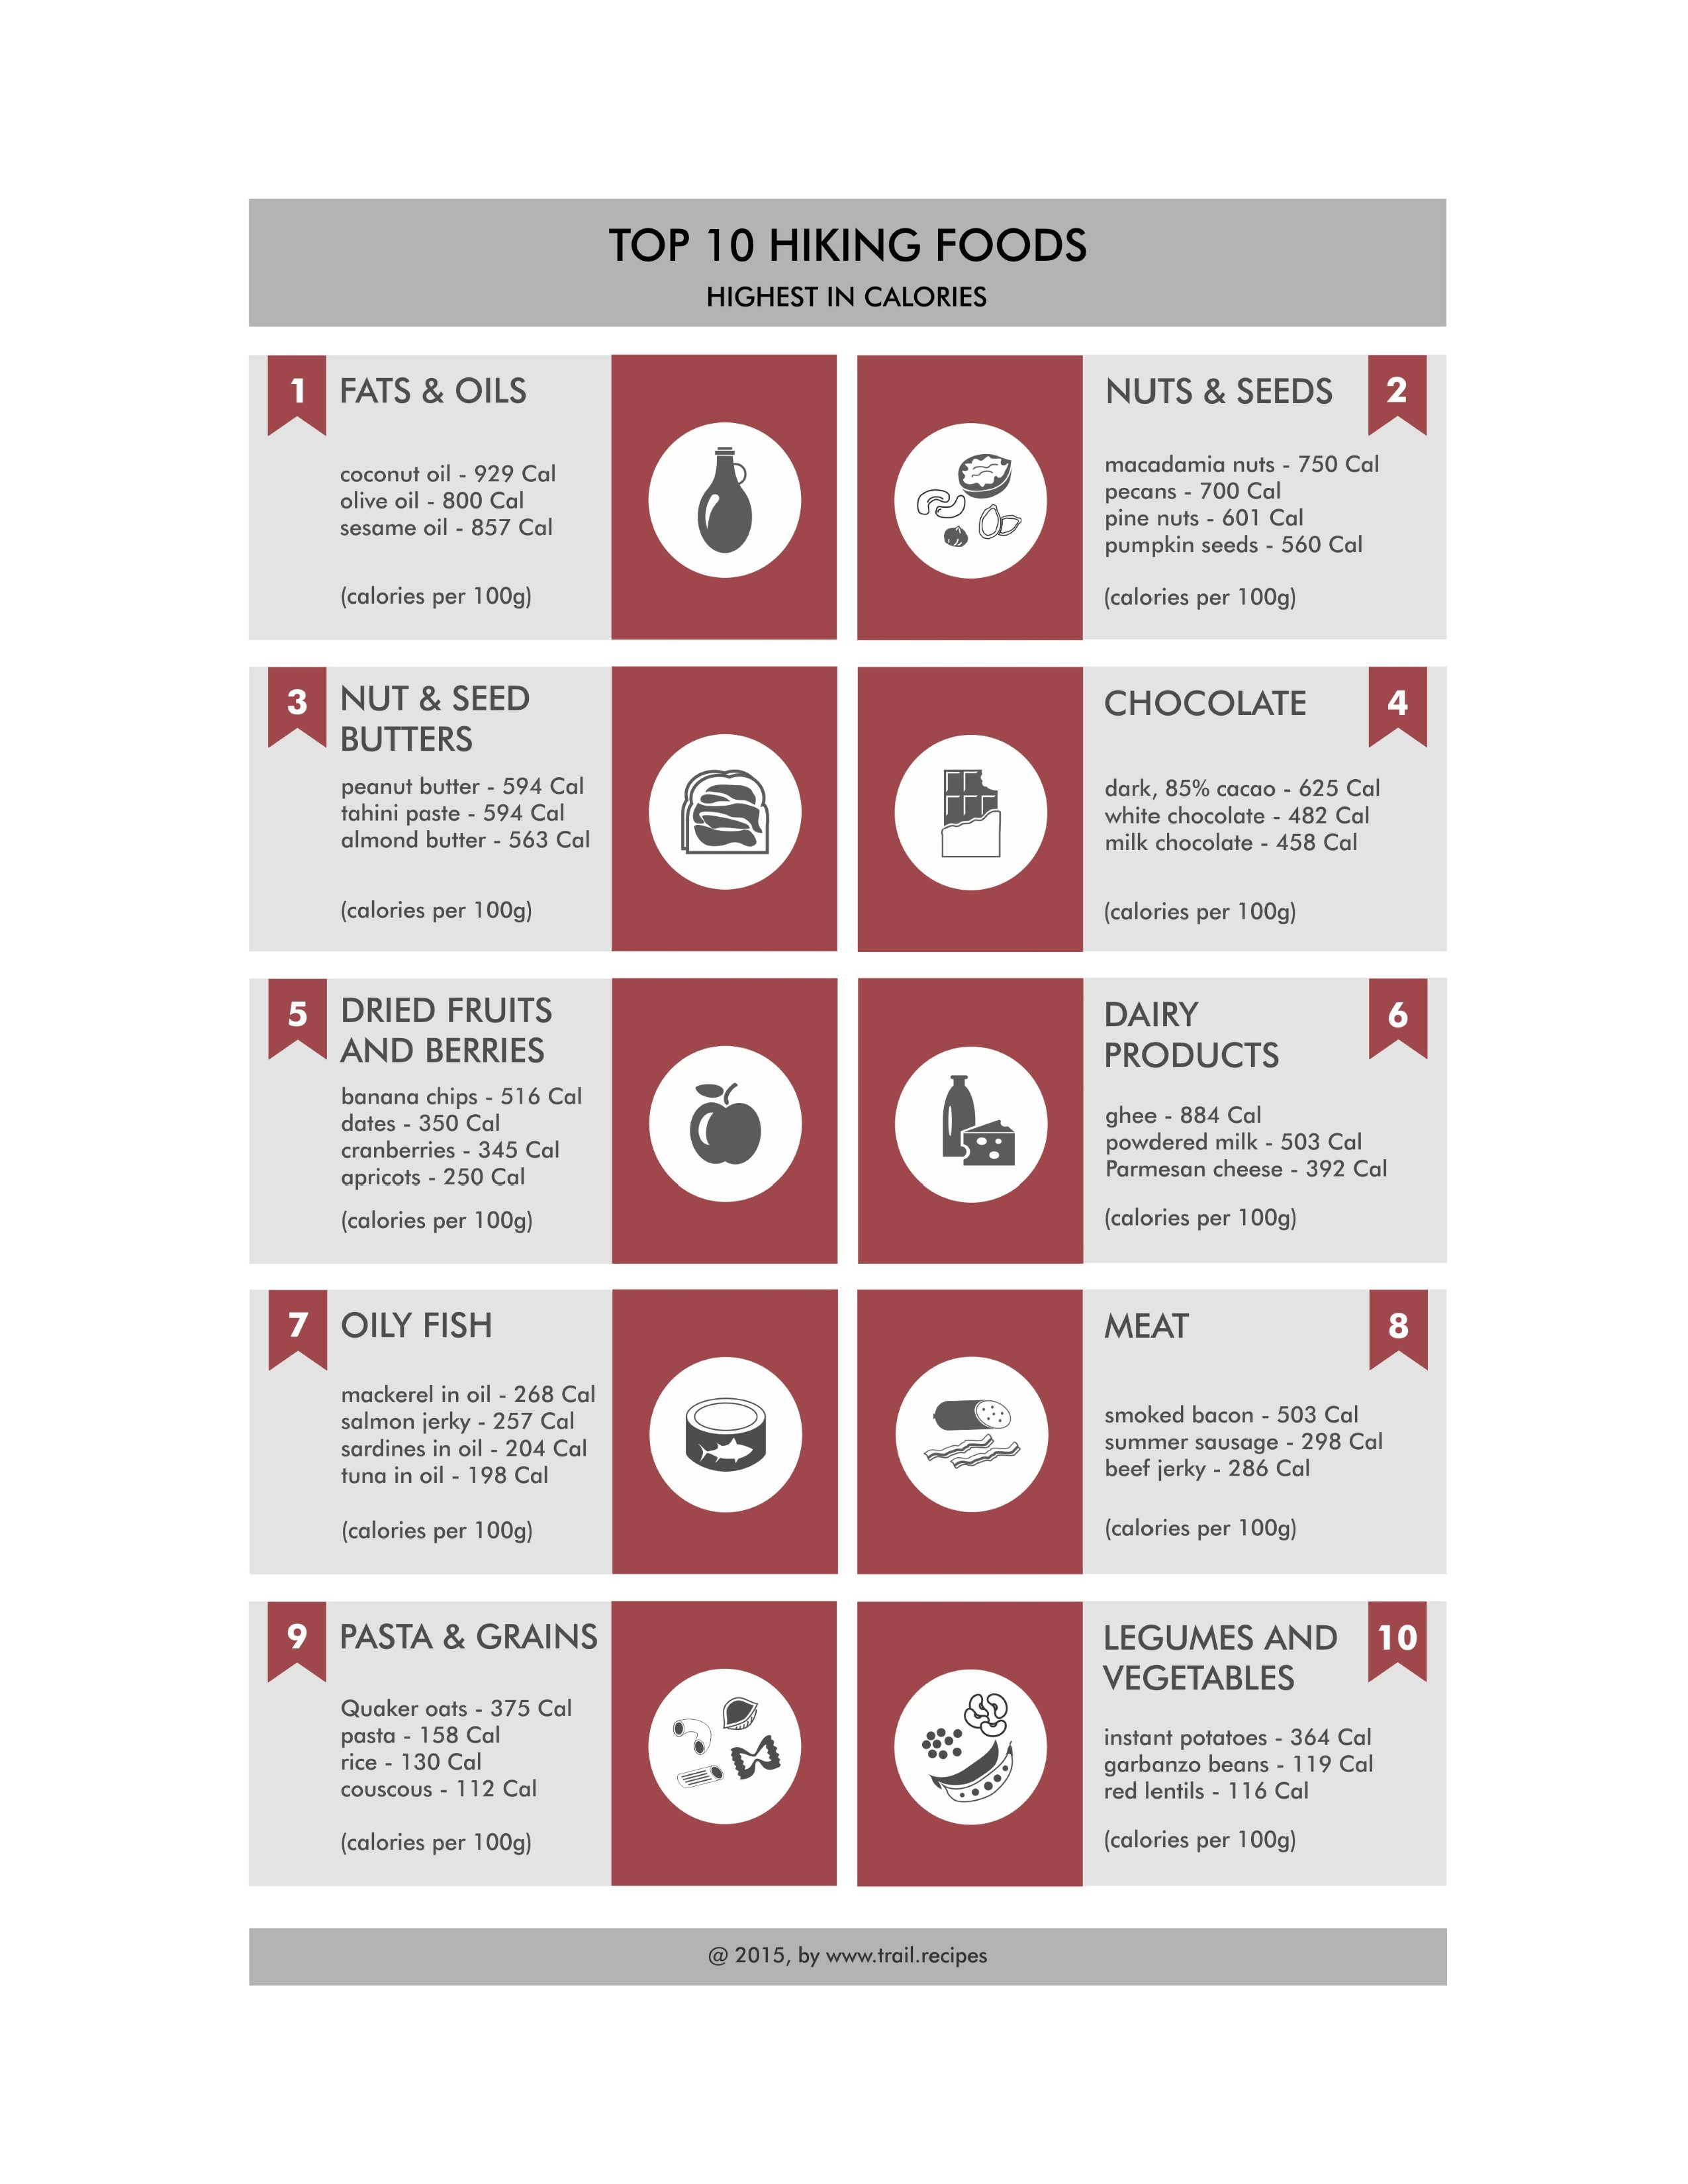
https://www.trail.recipes/backpacking-food-ideas/top-10-hiking-foods-highest-in-calories/

