Training Tips
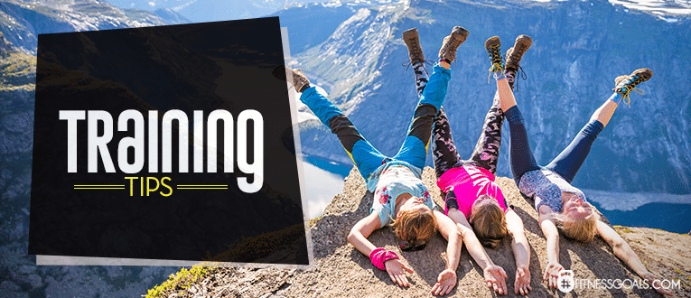
Hiking is the best way to get in shape for hiking, but that’s not always a possibility – especially if you’re an urban dweller. So, here are a few backpacking tips for women to prepare you for hiking before you actually step foot on your first trail.
– Walk. Simple as that. Walking is what you’ll be doing on the trail, so by simply walking to and from work, around your neighborhood, or following after your dog with a plastic bag on your hand, you’ll be improving your walking muscles and endurance.
– Take the stairs. This smart step (pun intended) mimics the movement of walking uphill, or at least uses the same muscles.
– Wear a backpack everywhere. If you’re planning on backpacking, it’s best to carry a pack over flat terrain first. Even a small pack can tax your upper body after a couple miles if you’re not used to it.
– Throw in a few lower body exercises to round out your preparation. Squats, lunges of all kinds, and explosive jumping movements (think plyometrics) will get those legs hiking-ready.

From the website:
http://fitnessgoals.com/beginners-guide-hiking-tips-advice/
